1. 
2. To create our Use-Case Diagram, we need to identify
   1. The System.
   2. The actors.
   3. The Use-Cases.  
      In the elevator system.
3. Let’s add it by dragging a use case subject onto the canvas & let’s call it “Elevator”.  
   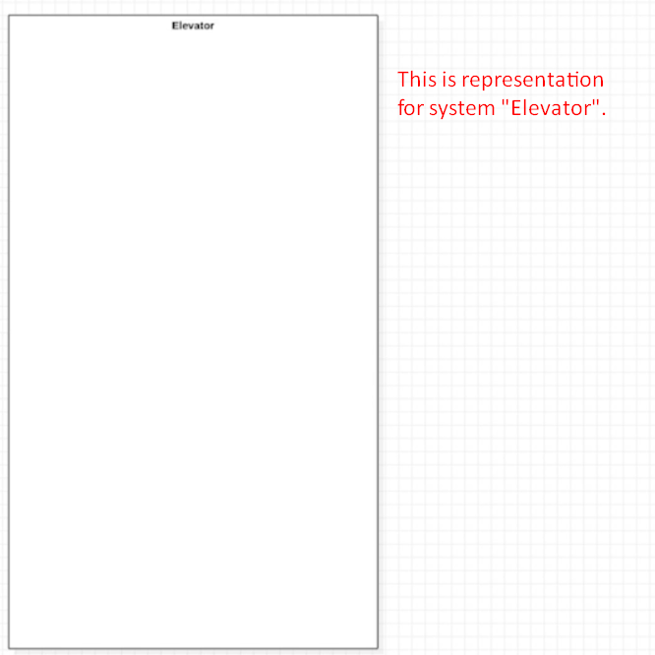
4. Elevator is designed to carry persons.  
   We can represent a single user as a single actor called “User”.  
   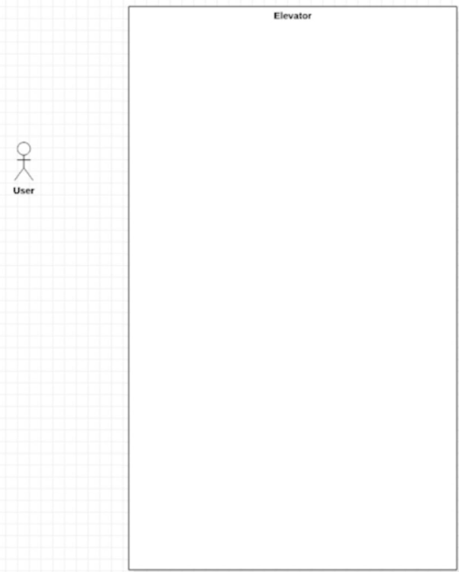
5. What does an actor “User” do with an elevator?  
   Let’s a look at the elevator control panel.
   1. A user calls elevator. This is a case.
   2. We add this case to our diagram and draw an association b/w the user and the use case.

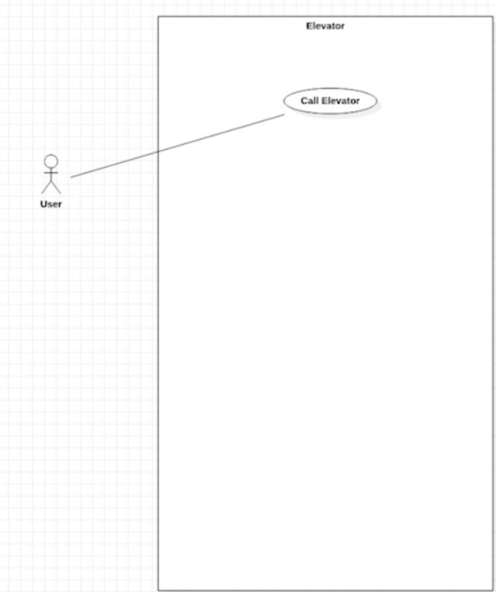

1. Then you select a floor. That is second use case. Let’s connect it with the Use-Case Diagram.  
   Then that elevator takes us to the selected floor. This action can be described as “Ride the Elevator”.  
   There are additional buttons on the panel. We can open and close the door. Let’s add one use case for this say “Operate Doors”.  
   Other Use Case: “Triggering Emergency Alarm”.
2. Elevators are essential tools that need to run safely and reliably.  
   Elevator mechanics are skilled technicians who are trained to install, maintain and repair them.  
   Let’s add one more actor for this “Technician” and use cases “Inspect Elevator”, “Service Elevator”, “Repair Elevator”.
3. 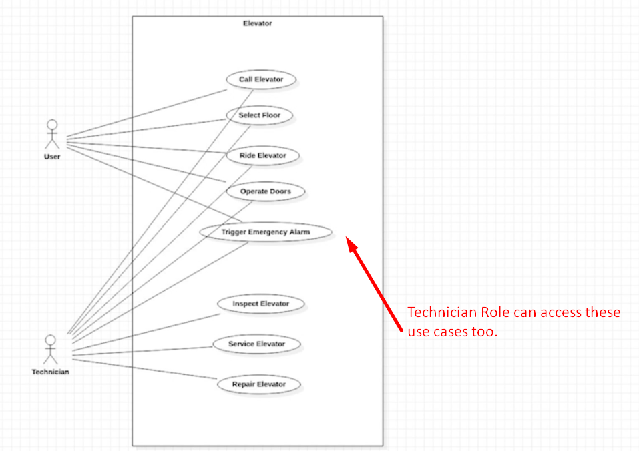
4. Use-Case Diagrams help us to understand the essential functional requirements of a system.
   1. They provide a quick external overview of the system.
5. Make sure to keep your use case diagram simple and focus on the actors and the textual use case descriptions.